Machine Learning II
Costumer Segmentation Final Report
Cluster Segmentation Analysis
Joana Nobre Martins (20241676), Maiara Almada (20241723), Mariana Martins (20241791)
NOVA Information Management School (NOVA IMS)

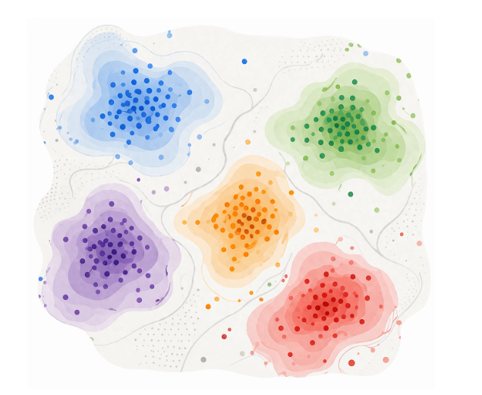

1. Executive Summary
This report presents the findings of a comprehensive customer segmentation analysis aimed at identifying distinct customer groups to drive targeted marketing strategies. By applying unsupervised machine learning techniques to customer demographics, spending habits, and historical transaction data, we successfully uncovered six natural customer segments.
These segments—ranging from "The Affluent Health-Conscious Buyer" to "The Promotion-Driven Pet Parent"—allow us to move away from generic marketing and instead tailor our promotions, product bundles, and communication strategies to the specific needs of each group. The insights derived from both the clustering models and association rules provide a clear roadmap for maximizing customer engagement, increasing basket size, and fostering long-term loyalty.

●
3) Customer Segmentation and Clustering
●
4) Targeted Promotion
●
5) Conclusion and recommendations

2. Exploratory Data Analysis and Pre-Processing
Performing an EDA is a crucial step in the data analysis pipeline, enabling the dataset to be properly prepared for subsequent modeling and analytical processes. The datasets provided—customer_info and customer_basket—contained comprehensive information on each customer's demographics and spending behavior, as well as detailed records of customers' purchasing baskets at the business.
Dataset Overview and Initial Assessment
To understand the structure and composition of the customer_info dataset, an overview of variables, data types, and summary statistics was conducted. This analysis revealed the existence of 25 variables: three categorical variables (customer_name, customer_gender, and customer_birthdate stored as objects), customer_id as an integer identifier, and the remaining variables stored as floats. Missing values were identified in eight variables across the dataset, while no duplicate customer_ids were detected, confirming data integrity. The customer_id was subsequently set as the index of the dataframe for proper data organization.
Feature Engineering and Variable Transformation
To enhance the analytical value of the dataset, comprehensive feature transformation was performed, creating new derived variables while modifying existing ones. This feature engineering was conducted in the early EDA phase to enable meaningful visualization and deeper insights into customer patterns.
The customer_gender variable was mapped to a new binary variable named female, where 1 represented female and 0 represented male. Similarly, loyalty_card_number was transformed into a binary variable called has_loyalty_card, where 1 indicated card ownership and 0 indicated no card, including cases where the original value was missing. Customer_birthdate was converted into a datetime series, enabling the creation of a new continuous variable, age, which captures the customer's age at the time of analysis.
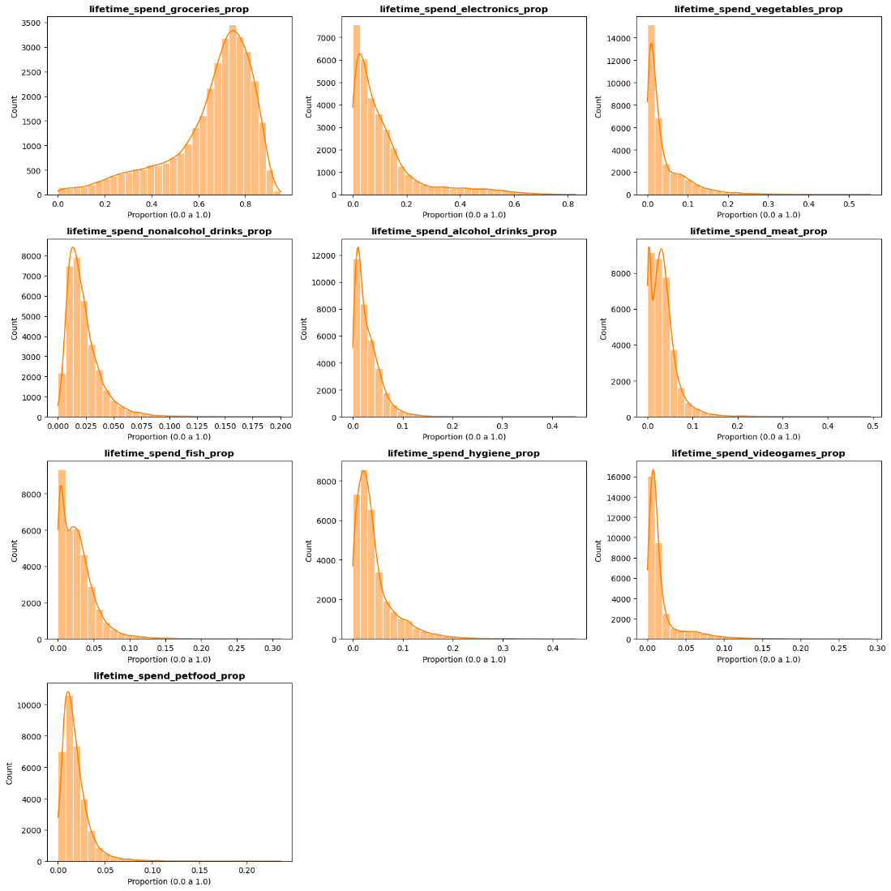
The spending features warranted special attention and multiple analytical conclusions. Initial analysis revealed that spending variables were severely right-skewed with multiple outliers, indicating they would require further transformation during the preprocessing phase. A critical insight emerged regarding the nature of spending patterns: customers with different absolute spending levels might exhibit similar purchasing preferences. For example, a customer spending €5 in the supermarket with all €5 allocated to fish products should potentially cluster with a customer spending €100 where the majority is also allocated to fish, as both exhibit the same spending pattern emphasis. Based on this logic, we created a set of new features representing relative spending proportions—the proportion of total spending allocated to each product category. These derived features also exhibited right-skewness and consequently required log transformations during the preprocessing stage to normalize their distributions.

All individual spending category features, including groceries, electronics, vegetables, and others, were aggregated into a single variable named total_lifetime_spend, capturing the customer's total spending across all categories. Additionally, a new variable called total_kids was created by summing kids_home and teens_home, as the analysis focused on the presence of children regardless of age. The original two variables were subsequently dropped to reduce dimensionality and avoid redundancy. Finally, a variable titled loyalty_to_product_type was created by dividing total_lifetime_spend by lifetime_total_distinct_products, representing spending concentration and identifying customers who are most exploratory in their purchasing behavior.
Data Quality and Validation
Analysis of value ranges for key variables revealed important findings. The typical_hour variable exhibited a valid range of 6 to 24 hours, confirming reasonable shopping time patterns. However, percentage_of_products_bought_promotion showed an inconsistent range of -0.48 to 1.20, which is mathematically problematic. Values exceeding 1 or negative values should not be possible for percentage measurements, indicating data quality issues that required investigation and correction during preprocessing.
Geographic Analysis
Leveraging the longitude and latitude coordinates of customer locations, a geometry variable was created using GeoPandas, enabling sophisticated geographical analysis of the customer base. As illustrated in Figure 1, the vast majority of customers are concentrated in central Lisbon, with smaller clusters observed in unexpected locations including the Tagus River, likely representing data entry errors, and the coastal areas of Ericeira and Peniche. This geographic concentration suggests that geographic location alone may not serve as a strong differentiator for customer segmentation, as most customers operate within a limited geographic area.
Moreover, the range of possible values for typical_hour (6h to 24h) and percentage_of_products_bought_promotion was calculated, showing an inconsistency in the latter (-0.48 to 1.20), since values higher than 1 or negative should not have been possible.
Having the longitude and latitude regarding the customers, a geometry variable was created using GeoPandas, making it possible for a geographical analysis of the customers (Figure 1). It can be noted that the vast majority of customers are in the centre of Lisbon, with some in the Tejo River and some in Ericeira and Peniche.

Additionally, we detected missing values across several numeric features which required careful imputation to maintain data integrity without distorting the natural distributions.
Data Pre-Processing Pipeline Based on the insights gathered during EDA, we implemented a robust pre-processing pipeline structured in four main steps:
1. Feature Selection and Dropping Non-Predictive Variables: To ensure our clustering algorithms grouped customers based purely on behavioral and relevant demographic traits, we removed variables that were either unique identifiers or lacked predictive value for this specific segmentation. The dropped columns included customer_id and customer_name (identifiers), has_loyalty_card and female (which showed low variance or irrelevance to the core spending behavior), as well as spatial data (latitude, longitude) to focus the segmentation primarily on purchasing habits rather than geographical location.
2. Handling Missing Values: Since completely dropping rows with missing values would result in valuable data loss, we opted for an imputation strategy. We applied a K-Nearest Neighbors (KNN) Imputer (n_neighbors=5) to all numeric columns. This sophisticated method allowed us to fill missing values based on the similarity of customers, ensuring that the imputed values accurately reflected the behavior of highly similar profiles.
3. Skewness Correction (Log Transformation): Because clustering algorithms (like K-Means) are distance-based and highly sensitive to extreme values, the right-skewed spending distributions posed a significant challenge. To normalize these distributions and pull in extreme outliers, we applied a Logarithmic Transformation (np.log1p) to all lifetime spending columns (e.g., lifetime_spend_electronics, total_lifetime_spend) and their corresponding spending proportion variables (prop). This transformation successfully stabilized the variance and made the data much more symmetric and algorithm-friendly. (Podes inserir aqui duas imagens de histogramas: "Before Log Transformation" e "After Log Transformation").
4. Data Scaling Strategy: Different features in our dataset had vastly different scales (e.g., age vs. total lifetime spend). To prevent variables with larger magnitudes from dominating the distance calculations in our clustering algorithms, feature scaling was mandatory. Instead of settling for a single method, our pipeline was engineered to output three distinct versions of the scaled data to test which yielded the best cluster separability:
- Standard Scaler: To standardize features by removing the mean and scaling to unit variance.
- Robust Scaler: To scale features using statistics that are robust to outliers (using the interquartile range).
- MinMax Scaler: To strictly bound all features within a 0 to 1 range.
By rigorously evaluating the algorithms across these three scaled datasets, we ensured the final segmentation was mathematically sound and optimal.

3. Customer Segmentation and Clustering

3.1. Methodology & Model Selection
To develop a robust and actionable customer segmentation, a rigorous workflow was built. Our objective was not only to identify the best statistical model, but to uncover the most interpretable and business-relevant customer personas. To start, multiple scaling techniques were tested, and MinMaxScaler was selected as the optimal normalization method, as it effectively bounded our features between 0 and 1, preserving the relative intensity of customer habits for subsequent analysis and with the highest silhouette score.
We evaluated five distinct clustering methods to uncover diverse behavioral patterns. We utilized centroid-based K-Means for stable, well-defined group partitioning and density-based models like Mean Shift and DBSCAN to capture non-linear, natural groupings of customer behaviors. Additionally, we employed Hierarchical clustering to identify nested consumer relationships through dendrogram analysis and applied neural-based Self-Organizing Maps to map complex, high-dimensional purchasing into a 2D grid.

3.2. Validation & Model Refinement
Models were validated using a dual-method approach combining quantitative and qualitative analysis. We leveraged the Silhouette Score as the primary diagnostic tool to measure cluster cohesion and separation, while simultaneously employing UMAP and t-SNE projections to visually inspect how well our segments were separated in 2D space.
Besides k=6, during our evaluation, we identified a vital lesson in model selection. While certain models, such as DBSCAN, produced mathematically superior Silhouette Scores of up to 0.89, they often resulted in degenerate clusters where most customers were forced into a single group, reflecting in zero conclusion about our customers personas. Consequently, we prioritized interpretability and segment balance over raw statistical metrics. The final ensemble model, which combines Hierarchical clustering and K-Means, was selected because it successfully converted raw transactional data into six distinct, balanced, and actionable personas that align perfectly with our strategic marketing goals.

3.3. Cluster Behavior Analysis

3.4. Association Rules & Market Basket Insights

3.5. Customer Personas & Strategic Profiles

4. Targeted Promotion

5. Conclusion and recommendations

